**BUFFALO PHOTO SHOOT**

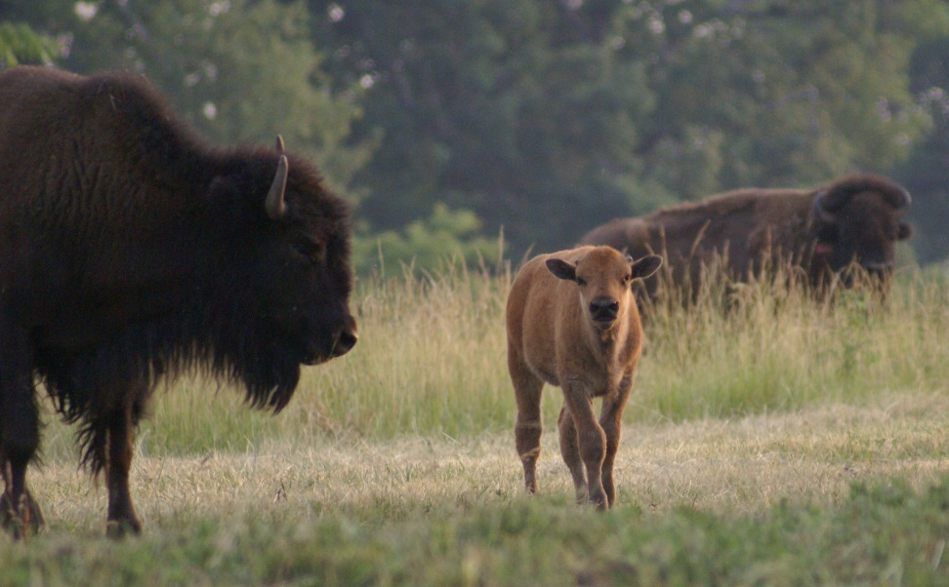

Join us for nonstop hayrides through the natural habitat of hundreds of buffalo at Twin Greeks Buffalo Farm *every* weekend in May.

* **Cost**: $5 for adults and $2 for children
* **Hours**: 9:00 a.m. to 6:00 p.m. Saturdays and Sundays
* **Questions**: 555-2838

Don’t Forget to Bring Your Camera!